- Keep consistent bedtimes and wake times every day of the week. Late weekend nights or sleeping-in can throw off a sleep schedule for days.
- Avoid spending lots of non-sleep time in bed — spending hours lying on a bed doing other activities before bedtime keeps our brains from associating the bed with sleep time.
- The bedroom should be cool, quiet and comfortable. Teenagers who stare at clocks should have their clocks turned away from them.
- Bedtime should follow a predictable sequence of events, such as brushing teeth and reading before bed.
- Avoid high stimulation activities just before bed, such as watching television, playing videogames, communication with friends, or exercise. Do not do these things during a nighttime awakening either. It is best not to have videogames, televisions, computers or phones in the teenager’s bedroom.
- Having physical exercise as a part of the day often helps with sleep time many hours later.
- Relaxation techniques such as performing deep, slow abdominal breaths or imagining positive scenes like being on a beach can help a teen relax.
- Avoid caffeine (sodas, chocolate, tea, coffee) in the afternoons/evenings. Even if caffeine doesn’t prevent falling asleep it can still lead to shallow sleep or frequent awakenings.
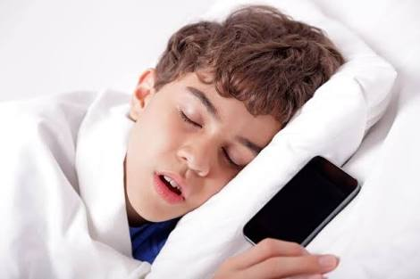
- If teenager is awake in bed tossing and turning, it is better for them to get out of bed to do a low stimulation activity, (i.e. reading) then return to bed later. This keeps the bed from becoming associated with sleeplessness. If still awake after 20-30 minutes, spend another 20 minutes out of bed before lying down again.
- Teenagers should be put to bed drowsy, but still awake. Letting them fall asleep other places forms habits that are difficult to break.
- Security objects at bedtime are often helpful for anyone who need a transition to feel safe and secure when their parent is not present. Sometimes these are obvious (a doll for a young child), sometimes they can be less obvious (a nearby picture of a loved one for a teenager)
- When checking on a teenager at night, checks should be “brief and boring.” The purpose is to reassure the child you are present and that they are okay.
- If your teenage is never drowsy at the planned bedtime, you can try a temporary delay of bedtime by 30-minute increments until the child appears sleepy, so that they experience falling asleep more quickly once they get into bed. The bedtime should then be gradually advanced earlier until the desired bed time is reached.
- Keep a sleep diary to keep track of naps, sleep times and activities to find patterns and target problem areas when things are not working.

